**COMP3121 Assignment 3 – Question 3**

**3)** We will need to find the minimum number of platforms that so that each train can stay at one of those platforms without interfering with other arrivals and departures.

To do this, we will first have to determine our initial counter value which would be the number of trains arriving before midnight and then leaving after midnight. Once we have this number, we can then create a list of departures and arrival times (which will be labelled as such) in increasing order so that we can then traverse through this list and adjust our counter accordingly. We will then use this counter to determine the maximum number of platforms that will be required at any one time, obtaining the largest number of platforms as such through a greedy algorithm. In other words:

Once we have obtained the number of trains where their arrival and departure times are respectively before and after midnight, we can initially fix that as the minimum number of platforms required. In order to determine if we should increase this number further, we will need to get the increasing list of arrival and departure times. We will then use a greedy algorithm which determines the trains that has the earliest departure time to ‘stab it’. We will then disregard any other trains which overlap with this time and then go to the next earliest departure time that we have not accounted for and so on. This is optimal as we can restrict ourselves to only ‘stabbing’ trains that satisfy the given property. This is similar to the practice problem described in the lectures and we can use the same diagram to explain the overlapping intervals.

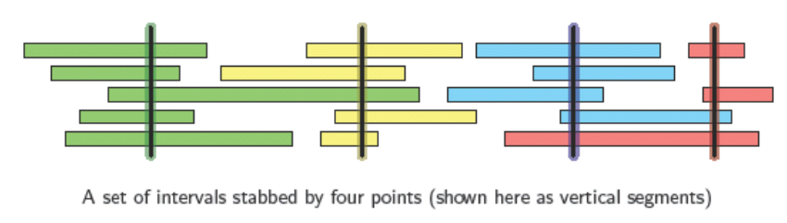

For each interval, we can find the greatest number of trains stabbed and compare this to our initial counter value. If our counter is smaller then we will need to increase it to this new number otherwise we can go to the next interval and repeat the process, eventually arriving at the minimum number of platforms that would be required to cater to these trains.

**End of Solution**